# Create a Todo App in SAP Build Apps Community Edition Part 3 – Create a Todo

This case assumes you finished Part 2 of Create a Todo App in SAP Build Apps Community Edition.

In this case, you will add a page with a form that allows the user to create a new Todo.

With the Todo app open, create a new page by clicking in the top right corner.

Click ADD NEW PAGE.

Name the page something like New Todo.

Open the new page by clicking on it.

Update the interface to look something like this:

Add an Input field below the Title control.

Use the Duplicate icon below the Input field control to create two new Input fields.

We need to activate the POST service in our Data resource, then create a Data variable on the New Todo page to bind to the Input fields. Click DATA in the top menu.

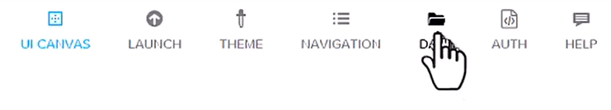

Select the Todo Data resource then select the CREATE RECORD (POST) service in the list on the left.

Enable the service by clicking the toggle on the top right.



The POST service doesn’t require any additional configuration.

If you click on the SCHEMA tab, you’ll see that it adopts the schema from the Get service.

Return to the UI CANVAS and click VARIABLES to create the Data variable.

Data Variables are used to connect to the Todo data resource Click DATA VARIABLES in the list on the left.

Then click ADD DATA VARIABLE on the right side of the screen and select the Todo data resource.

Select the new Data Variable then edit the properties as shown below.

Selecting New data record tells the app to use the POST service in the Todo Data Resource.

Return to VIEW. Select the first Input field. Change the Label to Todo, then click the X icon beneath Value.

Select Data and Variables.

Select Data Variable.

Bind the field to todo.

Now, change the labels of the second and third Input fields and bind them to description and dueDate.

Now, drag a Button control from the Toolbox below the last Input field and change Content to Save.

Click the black bar at the bottom of the screen to open the logic pane.

The button has a tap event. To configure the tap to call the POST service, scroll down to the DATA section in the toolbox on the left and drag the Create record component onto the logic pane.

Click on the small bump on the right side of Component tab and drag and drop on the Create record component.

Drag and drop on the Create record component.

Select the Create record component to open its Properties.

Since we only have one Data resource, the Todo resource is already configured. We just need to configure the properties to use the Data variable we bound to the Input fields. Click the icon to the left of Custom object.

Select Data and variables.

Select Data variable.

Select the NewTodo variable.

Complete the logic as shown below.

The top port on the right of Create record is executed if the todo create is successful. The Alert will just show a static message to indicate the Todo was created successfully. The Toast will execute if there is an error. Finally, when the user clicks OK on the Alert, the app will navigate back to the list page.

The last thing we have to do is to configure a button on the My Todos page to open the New Todo page. Navigate back to the My Todos page using by clicking the app name at the top left of the screen.

Select the My Todos page to open it. Note you must save the app before you can open a new page. Drag a Button control above the list. Change the label to something like New Todo.

Configure the button’s logic as shown.

Make sure you configure the Open page component to open the New Todo page.

Launch the app. Click the New Todo button.

Enter the data and click Save.

The Todo is saved, and the Alert is shown.

When you click OK, the app navigates back to the My Todos page and the new todo is on the list.

